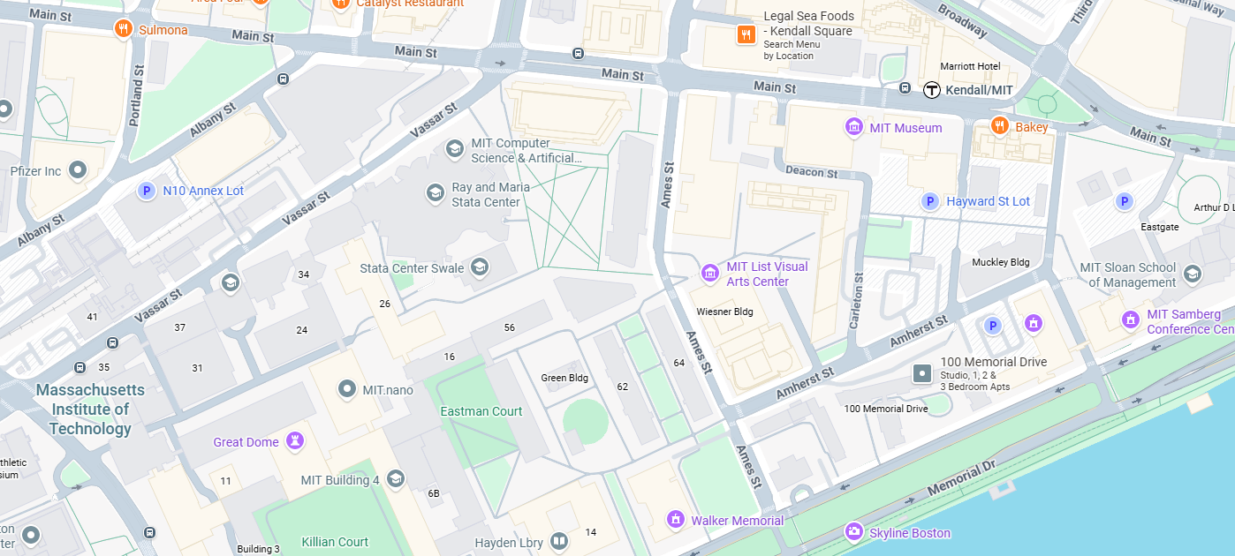
Hockfield Court
Koch Institute

If you get off of the MBTA Red line at Kendall Square you will set out and walk on Main Street towards Ames Street. Cross Ames Street, and turn left toward the Koch Institute. Go in between the Koch Institute and the Biology building, and walk towards the green quad (Hockfield Court).

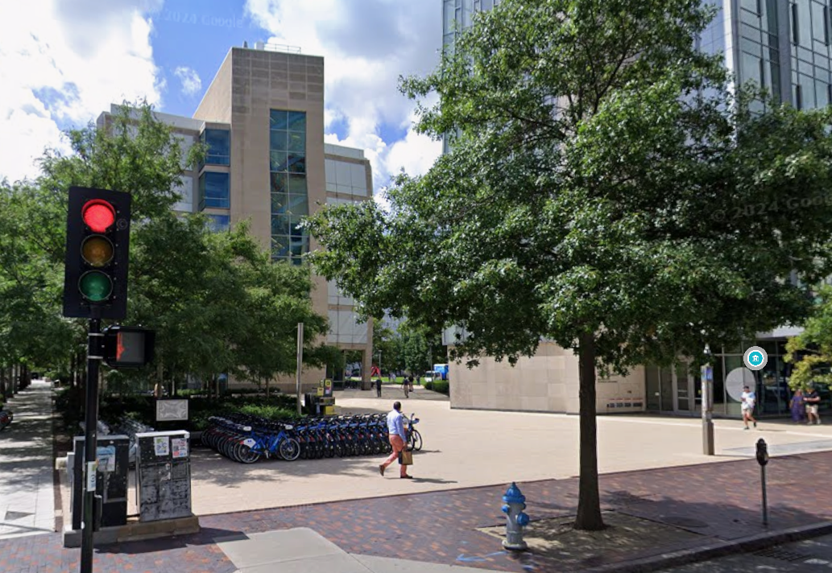

Walk straight across Hockfield Court, past the red art sculpture.

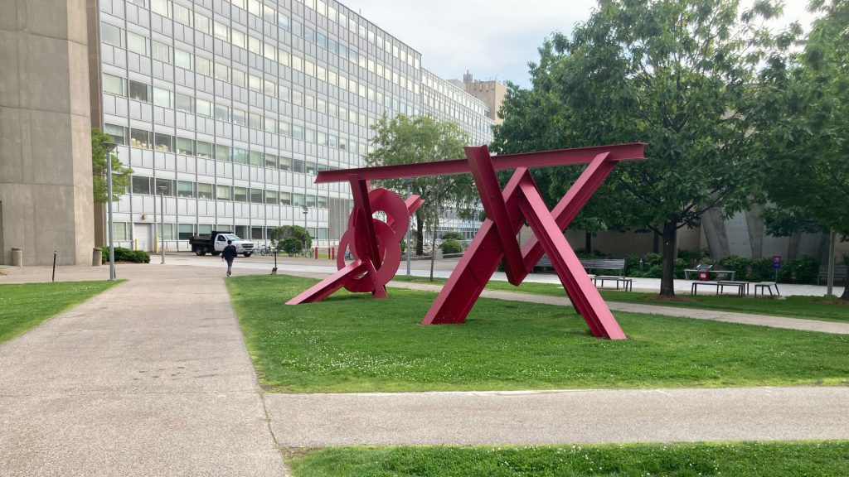

Turn slightly right and walk along the building with the glass windows.
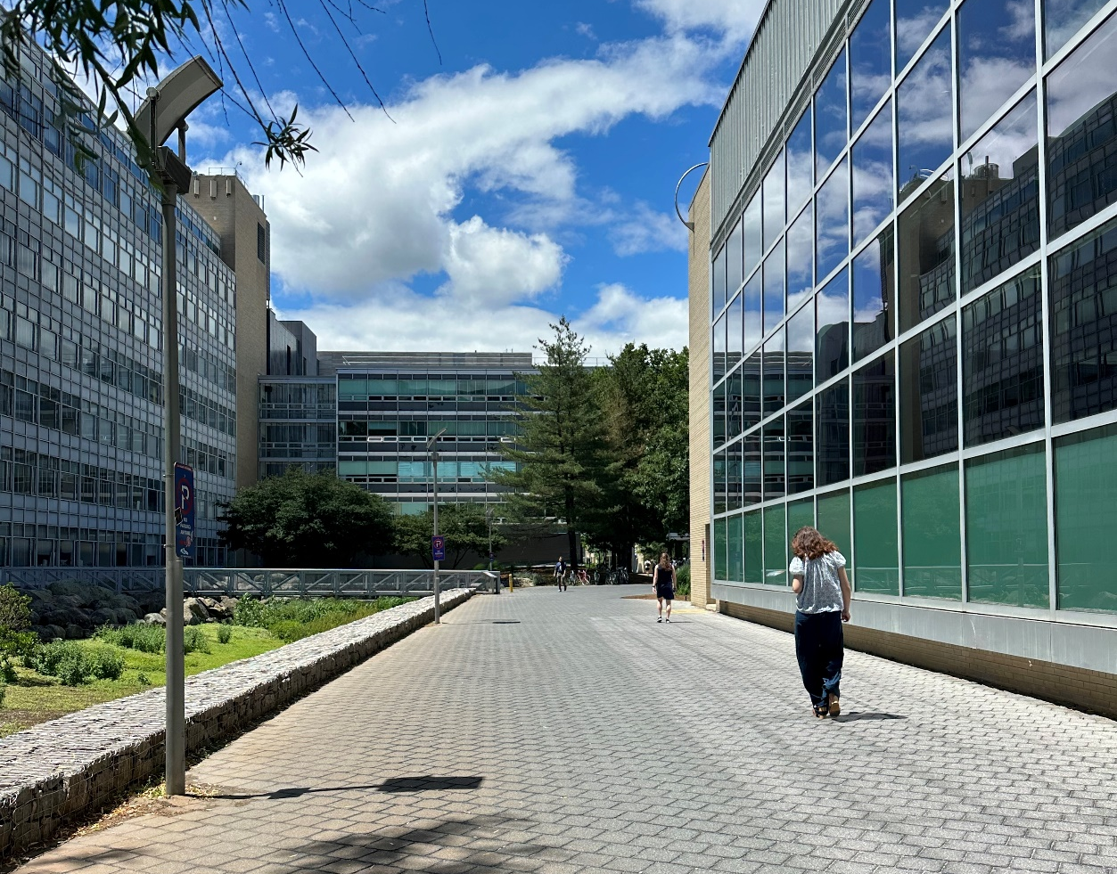
Continue walking until you reach the underpass with all the bicycles stationed.
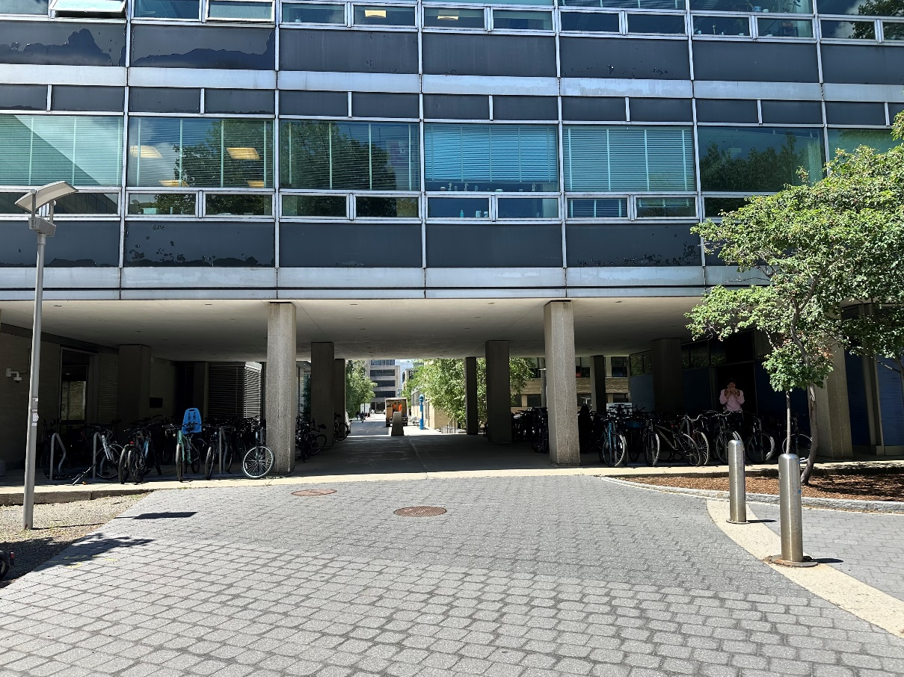
Enter Building 26 at the door to the right.
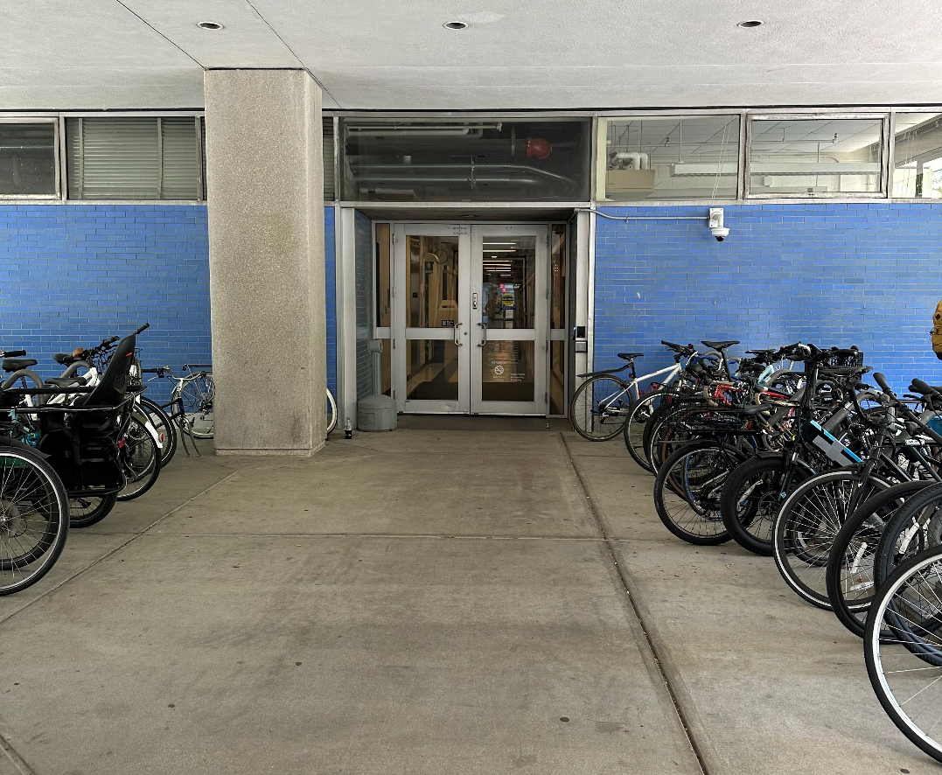
Once you arrive at Building 26, take the elevator to the 4th floor. Exit the elevator, turn left, and continue down the hallway until you see the RLE Conference Room on your left.

