May 27, 2021 DL@ARIEL minutes:

Richard circulated a slide to guide the discussion today:
DarkLight@ARIEL moving forward……
- Determine responsibilities of collaborating institutions
- Determine resources required to carry out the experiment
- Approach the funding agencies in Canada and U.S.
- Carry out design/simulations for optimized experiment
- magnet design
- simulations of detector performance
- calculation of backgrounds
- Consider a test experiment to measure backgrounds (Moller, e+e-,..)
- target foil
- existing spectrometers and detectors
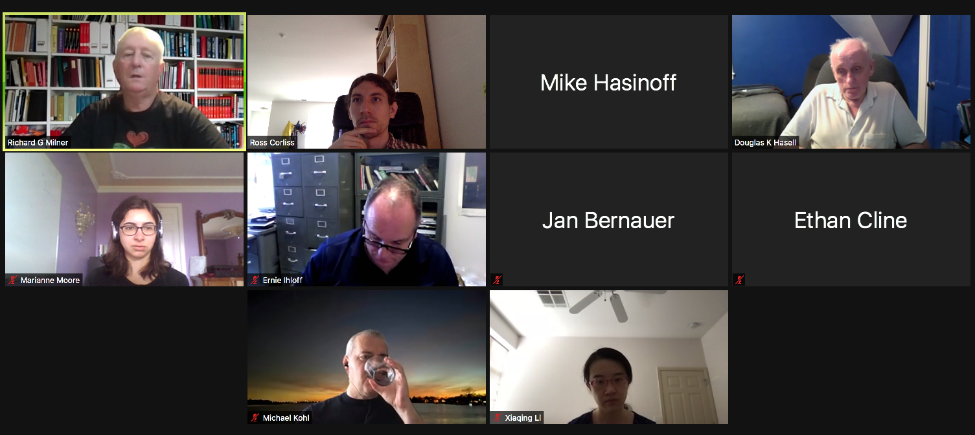
The current time of 2pm doesn't seem to work for TRIUMF people. Doug will send around a doodle, but we expect 1:30pm will be a better choice. In their absence, we focused more on the latter half of those bullet points.

Ernie will look at the max fields from the 1B/Moller experiment, and will calculate the fieldmaps so we can simulate expected performance.

We are looking at maybe using those two magnets. Ross points out we could use Jan's or Charles' simulation at a new energy to quickly check the expectations from the moller-like setup.

We also discussed iterating on the magnet design for the full experiment, to try to make things more uniform. A larger magnet acceptance would be preferred. Also, we want less mixing of the OOP and In Plane angles at the focal plane -- maybe poleface rotations can resolve this?

We expect that the detector angle optimization and the magnet optimization are mostly decoupled. The former is something Ross, Jan, and Marianne will discuss in the near future.

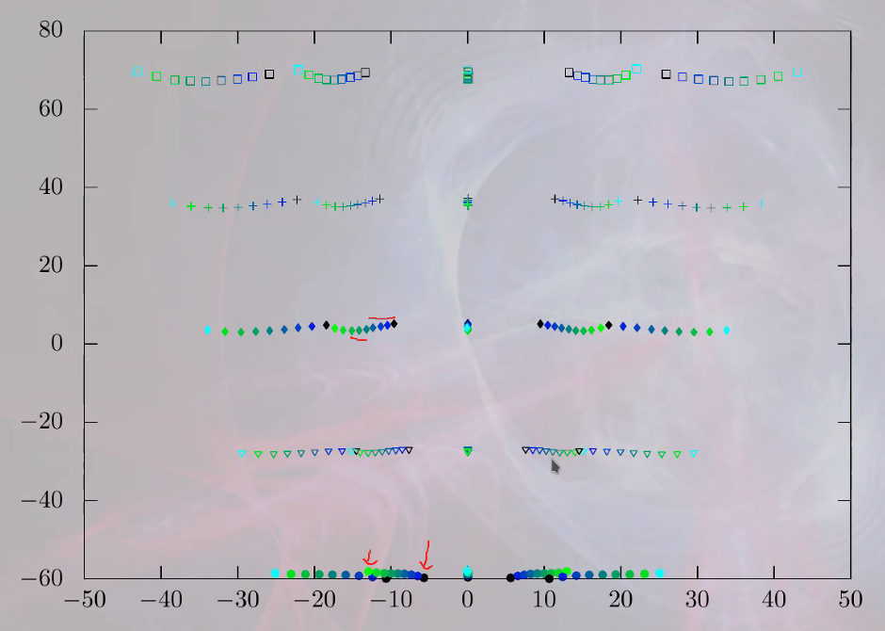
The dipole field nonuniformity (or path length difference) leads to degrouping of the different sets (each marker style is a fixed momentum and IP angle, with a different OOP angle indicated by color). Jan shared the plot from his simulation: Momentum maps to the vertical axis on the focal plane, IP angle plus OOP angle map to the horizontal access -- but we want OOP angle to have less effect, so we can get the invariant mass more quickly. Note the arrows -- the same IP angle gets confused with the next IP angle step when the OOP angle is sufficiently large.

The iteration on improving the field (a factor of 5 improvement in the effect would be desired (more is always better)) requires more expert understanding -- maybe a good thing to reach out to TRIUMF on?

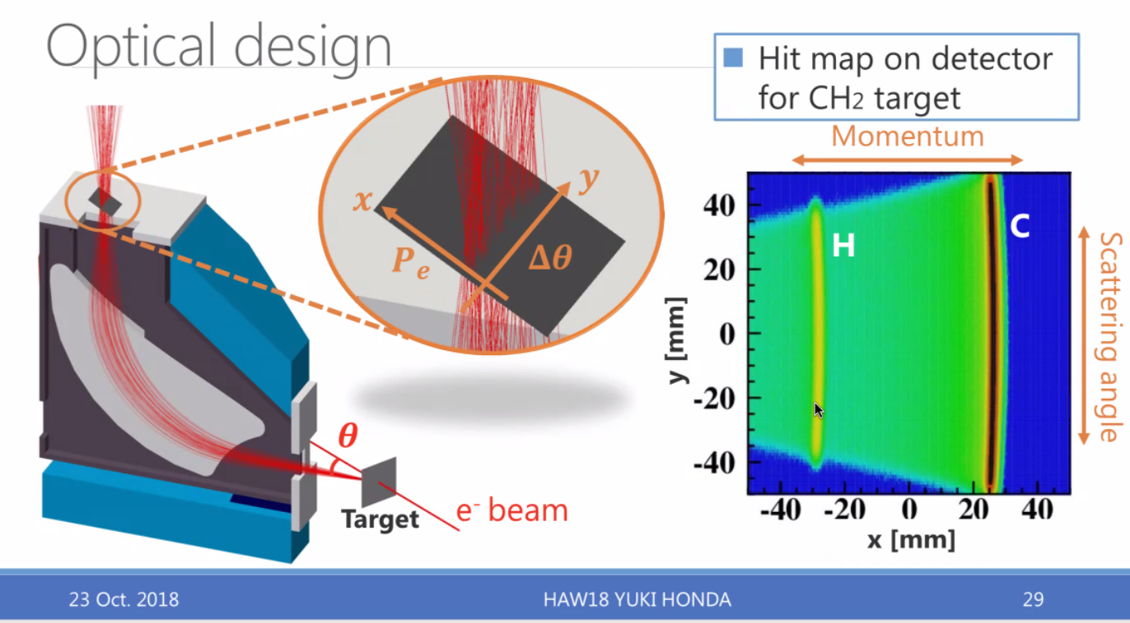
Michael pointed out the design of a japanese project ("ULQ2"). He will reach out to the group to see if they have a write-up or code they can share, and will send around slides.

